Galaxy Explorer: Mission to Pandora
Software Requirements Specification
Draft 1.0
September 19, 2016
Team Hydra

Revisions
Version | Primary Author(s) | Description of Version | Date Completed
Deliverable Draft 1.0 | Marcus Moss, Daniel Harris, Michael Holtman, Bess Burnett | This is the first version of the requirements elicitation document for Galaxy Explorer: Mission to Pandora. | 09/19/2016

Contents
1 Introduction 1
1.1 Purpose 1
1.2 Scope 1
1.3 Definitions, Acronyms, and Abbreviations 1
1.4 References 1
1.5 Overview 2
2 Overall Description 3
2.1 Product Perspective 3
2.2 Product Functions 3
2.3 User Characteristics 3
2.4 Constraints 3
2.5 Assumptions and Dependencies 3
2.6 Apportioning of Requirements 3
3 Specific Requirements 4
3.1 Over All Game Description 4
3.1.1 Rooms 5
3.1.2 Monsters 18
3.1.3 Puzzles 20
3.1.4 Items 21
3.1.5 User Interfaces 22
3.2 Software Product Features 22
3.2.1 Main Menu 22
3.2.2 Room Menu 25
3.2.3 Fight Monster 26
3.2.4 Solve Puzzle 28
3.3 Performance Requirements 29
3.4 Design Constraints 30
3.5 Software System Attributes 30
3.6 Logical Database Requirements 30
3.7 Other Requirements 30

Introduction

Purpose
The purpose of this document is to describe the text based adventure game "Galaxy Explorer mission to Pandora" (GEMP). It will detail how the game is played as well as detailing any constraints placed on the game.

Scope
The scope of the text based adventure game "Galaxy Explorer" is to create a fun interactive learning game, that will help teach computer interaction and enhance critical thinking skills. There are no software or hardware constraints at this time.

Definitions, Acronyms, and Abbreviations
Acronyms /Abbreviation | Definition
UID | Unique ID number
DESC | Description that is given to the player of any object they interact with
LOE | List of exits
CL | Creature list
PL | Puzzle list
IL | Items list
DEP | Dependency: gives a list of requirements that must be accomplished first

References
Whaley, Andrew. "Play Text Adventures Online." Play Text Adventures Online. N.p., n.d. Web. 09 Sept. 2016.

BrainDen.com
Jan Adamovic - http://brainden.com/logic-riddles.htm

Bruegge, Bernd, and Allen H. Dutoit. Object Oriented Software Engineering. Third ed. Upper Saddle River: Pearson Education, 2010. Print.

Overview
There are three major sections in this document. Section one provides the generalized overview of the scope and purpose of "Galaxy Explorer mission to Pandora". Section two provides the information for this specific game. Section three is an outline of the game requirements.

Overall Description

Product Perspective
This game is self-contained and independent from other systems.

Product Functions
With this game the player will have the ability to explore a damaged ship traveling in space with the goal of repairing the ship to reach its destination. They will have to fight monsters and solve puzzles to earn items and energy cells.

User Characteristics
The game has two users an administrator and player.

The player can open the game and either load a previous game or start a new one. Once the game has started they can play the game by moving between rooms, fighting monsters, and solving puzzles. They can also save the game at predetermined save points. They may exit the game at any time but can only save a save points.

The administrator will have the ability to change/add the puzzles, monsters, and play attributes.

Constraints
This game needs the ability to run on PC's. It will also need to accurately move from room to room and track monsters/puzzles that have been completed.

This is a single player game therefor there is no need for parallel operations or higher-order language requirements.

Assumptions and Dependencies
Players will need to have the ability to read at a fifth grade level. They also need to have some rudimentary computer science and problem solving skills.

Apportioning of Requirements
There are not requirements that should need to be moved to the next release of the game.

Specific Requirements

Over All Game Description
NEWS FLASH
Today’s the day folks, after years of research and planning the first space voyage that requires its members to be placed into stasis happens today. In just a few moments we will watch live as the crew is launched on this momentous journey. Their destination is a planet which they believe will support life as we know it. The journey is so long that the crew will have to be placed in stasis for the duration. Each crew member has been carefully selected to ensure the crew has a good mix of skill sets to colonize this new planet. Once launched we will receive word from the pilot confirming all systems are operational before the pilot joins the rest of his crew in stasis. After this we will have no contact with the human crew until they reach their destination. Our thoughts and prayers will be with these brave men and women.

At launch site
It’s finally the day, you were selected for this mission almost two years ago. Since then you've spent hours upon hours learning about the ship so you can be the most effective ship engineer you can be. There’s been countless plans and meetings and check-ups but it has all been worth it because now you’re walking into the ship which will take you to an entirely unknown planet. One of the many doctors comes up and begins fitting you with wires and monitors that will keep your body alive during the journey. They tell you not to worry it’ll just feel like you’re going to sleep and when you wake up you’ll be somewhere new. A nurse comes over and with the doctor the two get you situated in the pod and begin hooking up wires.
“Are you ready?”, the doctor asks.
You nod, too nervous to speak. The doctor smiles lightly and presses some buttons, the world begins to grey and you let your eyes slide closed secure in the knowledge when you wake you’ll be at a new planet.

Level 1 goal: open the command center
Level 2 goal: power up the ship's AI
Level 3 goal: power up the engine room
Level 4 goal (final): power up the navigation then return to the command center to fly off
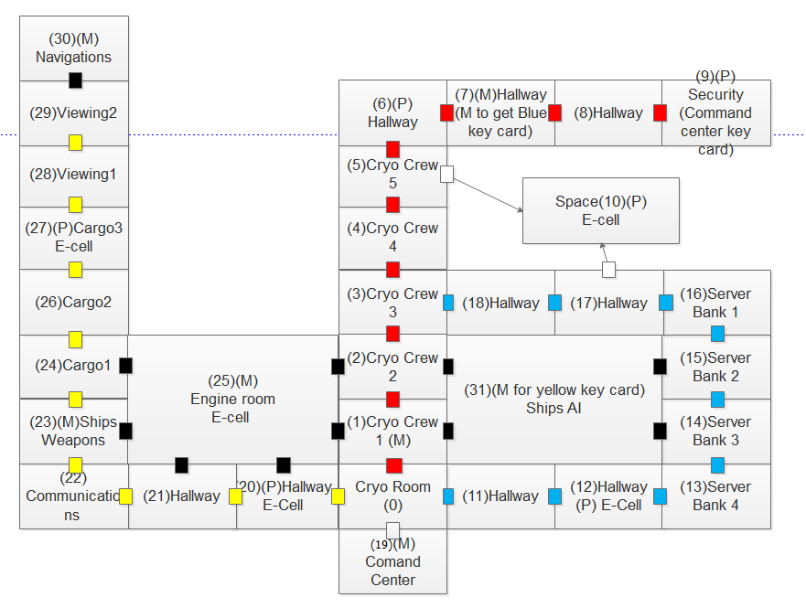

Rooms
UID | 0r
Name | Cryo Room
LOE | Red door (north-1r), Blue door (east-11r), Yellow door (west-20r), Command Center Door (south-19r)
IL | Red key
CL | null
PL | null
DESC | First time description: You begin waking up, your eyes are gritty and your head is foggy. You glance around and unease starts to creep in. You were supposed to be at a new planet, there should be others around, and more light or sounds, anything. Gingerly you sit up and unhook yourself, you call out but the only response is your own voice echoing back to you. The lights are dim and you can’t even hear the whooshing that would indicate the environmental system is running. The other chambers are still closed and hold crew members who appear to still be in stasis. You begin to think something must have happened to the ship so you get up to investigate and you find a red key card that’s been thrown to the ground.  After a few minutes to orient yourself you realize that the red door leads up towards Security which you know holds extra command center key cards. Thanks to your knowledge of the ship you know you need to get to the AI to figure out what happened and why you're the only crew member awake.  All other times: The room has 4 doors and each door has a name plate above it. To the west is a yellow door marked, to the east is a blue door both marked "Hallway". The south holds a grey door labeled "Command Center" and to the north is a red door labeled "Cryogenics Room".

UID | 1r
Name | Cryo Room 1
LOE | Red door (south-0r), Black door (west-25r), Red door (north-2r), Black door (east-31r)
IL | Lead Pipe - 4i
CL | Rogue Cleaning Unit
PL | null
DESC | The walls are dull grey and lined with the stasis units for other crew members, they too appear fine, just out. When you enter the room you're attacked by a Rouge Cleaning Unit. You Pick up the lead pipe to start attacking with  The room has 4 doors and each door has a name plate above it. To the west and east there are black doors, the west is labeled "Engine Room" and the east is labeled "Ship AI". To the north and south are red doors labeled "Cryogenics Room".

UID | 2r
Name | Cryo Room 2
LOE | Red door (south-1r), Black door (west-25r), Red door (north-3r), Black door (east-31r)
IL | null
CL | null
PL | null
DESC | The crew in this rooms appears to be fine as well, sleeping in their chambers.  The room is a dull metal grey with four doors each with a name plate. To the west and east there are black doors, the west is labeled "Engine Room" and the east is labeled "Ship AI". To the north and south are red doors labeled "Cryogenics Room".

UID | 3r
Name | Cryo Room 3
LOE | Red door (south-2r), Red door (north-4r), Blue door (east-18r)
IL | null
CL | null
PL | null
DESC | The room is a dull metal grey with three doors each with a name plate. To the north and south are red doors both labeled "Cryogenics Room". To the east is a blue door labeled "Hallway". The walls are lined with the stasis units for other crew members.

UID | 4r
Name | Cryo Room 4
LOE | Red door (south-3r), Red door (north-5r)
IL | null
CL | null
PL | null
DESC | The room is dull metal grey with two doors, one to the north and one to the south. They are both red and labeled "Cryogenics Room". The crew in this room appears fine.

UID | 5r
Name | Cryo Room 5
LOE | Red door (south-4r), Red door (north-6r), Windowed door (east-10r)
IL | null
CL | null
PL | null
DESC | The room is dull metal grey with three doors, the north and south door are both red. The south door is labeled "Cryogenics" and the north is "Hallway". The door to the east is the same dull grey as the rest of the ship but there appears to be a window near the top. You give the stasis chambers a quick glance to ensure the crew is fine then go to check the window.  The window is small but you can just make out what appears to be a room with something in it. As you step back your foot catches against something on the floor. Upon inspection, you realize there is an anchor point on the floor next to the door.

UID | 6r
Name | Hallway
LOE | Red door (south-5r), Red door (east-7r)
IL | Energy crate, energy cell
CL | null
PL | Binary puzzle
DESC | The room is grey with two exits, a red door to the south labeled "Cryogenics" and another red door to the east labeled "Hallway". In the far corner is a crate with a slowing blinking light on the front. When the light blinks on you can see a number pad underneath.

UID | 7r
Name | Hallway 1
LOE | Red door (west-6r), Red door (east-8r)
IL | Blue Key Card
CL | 7M – cyborg pirate
PL | null
DESC | The grey walls continue into this room as do the red doors. The west and east doors are labeled "Hallway". When you enter you're attacked by cyborg pirate.  Once you defeat the monster it drops a blue key card.

UID | 8r
Name | Hallway 2
LOE | Red door (west - r7), Security door (east - r9)
IL | null
CL | null
PL | null
DESC | The walls are grey and there are two doors, the west door is read and labeled "Hallway" and the red east door, much to your relief, is labeled "Security".

UID | 9r
Name | Security
LOE | Red door (west -r8)
IL | Command Center Key Card, Rope
CL | null
PL | Magic square
DESC | Just like the other rooms it is dull gray but with a flickering overhead light. Looking around the room the all the monitors are static except for the one in the command center which appears to be in working order. On the wall there is a rope and other items.  Looking out the window you see an energy cell crate it's a room that appears to be leaking atmosphere into space.  Remembering that there is an extra key card to the Command room you start to look around and find a vault under the desk. Having never been told the code you try to hack into it by solving the magic square puzzle.

UID | 10r
Name | Spaced Energy Cell
LOE | Can only go back to the room you can through with the rope
IL | E-cell
CL | null
PL | Binary Puzzle
DESC | (Without rope) you are violently sucked out into the vacuums of space.  (With rope) Once the door is pried open the air is sucking around you pulling you to the leaking hole. Crawling around the wall you have reached the E-Cell create.  After finishing the puzzle and starting to crawl back to the open door with your rope. Looking around you notice that it appears that the ships AI rooms are not damaged, giving hope that the ship is still salvageable.

UID | 11r
Name | Hallway 3
LOE | Blue Door (east - r3), Blue Door (west - r12)
IL | null
CL | null
PL | null
DESC | Another hallway with dull gray walls  Each door in the room has a nameplate above it; the blue door to the West reads "To Cryo Room", and the Blue door to the East reads "To Server Rooms"

UID | 12r
Name | Hallway4
LOE | Blue Door (east - r11), Blue Door (west - r13)
IL | Energy Cell
CL | null
PL | Binary Puzzle
DESC | Like most of the hallways on the ship this is another dull gray walled room. There is a E-Cell crate sitting on its side in the far corner of the room.  Each door in the room has a nameplate above it; the blue door to the West reads "To Cryo Room", and the Blue door to the East reads "Server Room 4"

UID | 13r
Name | Server Bank 4
LOE | Blue Door (West - r12), Blue Door (North – r14)
IL | null
CL | null
PL | null
DESC | This room is abnormally dark even compared to the crippled ship. The light blinking on the server bank are creating a dancing shadow effect, giving a serial effect.  Each door in the room has a nameplate above it; the blue door to the West reads "To Cryo Room", and the Blue door to the South reads "Server Room 3"

UID | 14r
Name | Server Bank 3
LOE | Blue Door (South-13r), Blue Door (North-15r), Black Door (West-31r)(Locked by control room)
IL | null
CL | null
PL | null
DESC | You're struck by how well this room is intact and seems to be in working order. All server banks seem to be powered on and communicating with the main system.  Each door in the room has a nameplate above it; the blue door to the north reads "Server Bank 2", the Blue door to the South reads "Server Room 4", and the black door to the West reads "AI"

UID | 15r
Name | Server Bank 2
LOE | Black Door (West-31r)(Locked by control room), Blue Door (North-16r), Blue Door (South-14r)
IL | Null
CL | Null
PL | null
DESC | This room largely resembles the others, with black server racks occupying most of the space.  Each door in the room has a nameplate above it; the black door to the west reads "AI", the blue door to the north reads "Server Bank 1", and the blue door to the south reads "Server Bank 3".

UID | 16r
Name | Server Bank 1
LOE | Blue Door (South-15r), Blue Door (West-17r)
IL | Null
CL | Null
PL | null
DESC | Besides the usual grey, the walls of this room are lined with blade servers, most of which remain relatively unscathed.  The blue door to the west leads towards the cryogenic rooms, and the blue door to the south has a nameplate above it, reading "Server Bank 2".

UID | 17r
Name | Hallway 4
LOE | Blue Door (West-18r), Ice Door (North-10r), Blue Door (East-16r)
IL | Null
CL | null
PL | Ice Door
DESC | These hallways all look the same, with the only indication that you've moved being the signs on the floor. That, and the fact that this room is just as cold as the cryogenic rooms.  (If Ice Door Unsolved) To the west, there is a hallway leading to a cryogenic room, and the door on the eastern wall has the words "Server Bank 1" written over it. The door to the north is completely covered in ice, and you cannot determine where it goes from where you stand.  (If Ice Door Solved) To the west, there is a hallway leading to a cryogenic room, and the door on the eastern wall has the words "Server Bank 1" written over it. The door to the north leads to an unmarked room.  (Investigating frozen door) The northern door is totally sealed by a barrier of ice, which seems to be emitting a frosty powder. It is cold to the touch, but does not seem to be actively refrigerated. It will probably melt, given enough time.  (If you have collected the weapon from 4M or 6M) Time that you do not have. Standing a short distance away, you aim your makeshift heater at the door, and in a few minutes, have it melted enough to open.

UID | 18r
Name | Hallway 5
LOE | Blue Door (West-3r), Blue Door (East-17r)
IL | Null
CL | Null
PL | null
DESC | The walls of this hallway are a uniform grey throughout. Only about a quarter of the lights are working, so it is fairly dark.  The door to the west has the words "Cryogenics Room" written above it, and to the east, there is the rest of the hallway leading to a server bank.

UID | 19r
Name | Command Center
LOE | Command Door (north-0r)
IL | Null
CL | Tunneling Horror (3M)
PL | null
DESC | (first entrance) When you enter, the room is lit only by back power making it very dim.  (if you have an energy cell) Knowing where the energy cell for the room goes you turn right and begin to make your way cautiously along the wall until you hit the console along the west wall. Once there you kneel down and pry open the panel that holds the dead energy cell, you carefully pull it loose and set it to the side. Pulling out your found cell you plug it in to the console. The lights come on and you turn to inspect the room.  The south wall holds a bank of consoles, in the center is a map of the ship showing which areas were damaged. Upon inspection you realize none of the critical areas are beyond help, they all just appear to be low on power. Since you've already powered the command center, the AI room doors have power and you unlock them from the console. You try to unlock the other doors as well but there isn't sufficient power in the ship yet.  On the east side where normally sits extra storage crates there is a huge monster (3M). The monster doesn't appear overly mobile but it is gnawing at the walls, which could become a problem given the rooms proximity to the edge of the ship.

UID | 20r
Name | Hallway 6
LOE | Yellow Door (West-18r), Black Door (North-25r), Yellow Door (East-0r)
IL | Energy Cell
CL | null
PL | Binary Puzzle
DESC | (If 10M not fought) The hallway towards Communications is long, and includes two sections. The walls are a neutral grey in color, with the outlines of wall panels visible in some places. In the northeast corner of this hallway, near the cryo room door, sits an energy cell chest.  (If 10M fought) This section of the hallway seems more damaged than the other. There are panels missing from the walls, with severed, sparking wires protruding from them, and the walkway is deformed. The energy cell chest that was in the corner is crushed along with that entire wall. (Note, if you somehow managed to get through here without getting the cell, it is now permanently lost)  To the west is to the second section of the hallway towards the comm room, and to the east is the cryo room. The door to the north has the word "Engine" written over it.

UID | 21r
Name | Hallway 7
LOE | Yellow Door (West-22r), Black Door (North-25r), Yellow Door (East-20r)
IL | Null
CL | Null
PL | null
DESC | (If 10M not fought) The second section of the hallway towards the com room seems identical to the first, though it is missing the energy cell chest.  (If 10M fought) The second section of the hallway towards the comm room shows signs of the recent attack, with sections of the outer hull visibly bent inward.  To the west is Communications, and to the rest of the hallway towards the cryo room. The door to the north has the word "Engine" written over it.

UID | 22r
Name | Communications
LOE | Yellow Door (West-18r), Black Door (North-25r), Yellow Door (East-0r)
IL | Null
CL | null
PL | Unspecified Communications Puzzle of Relatively High Difficulty
DESC | This room is a uniform drab grey like the others. A few computer terminals with blinking lights populate the otherwise sparsely furnished room.  (If first entry) A large pair of monitors stand out among the rest, with the first one featuring what appears to be a sonar. It shows your ship as a white dot in the center, with various smaller grey dots spread out, probably debris. However, there is also a much larger red dot, which the computer has calculated is rapidly approaching. The second monitor displays a rapidly-scrolling command line interface. The window is titled "Distress Signal Broadcast", and it just seems to be repeating the same error: "Error: Radio Silence Initialization exited with error code 0x88D710F3. Extended signal broadcast may attract pests." You might want to try turning this thing off.  (If gave up) There is no fixing it now. Hopefully it is harmless.  To the east is the hallway leading to the cryogenic rooms, while the door to the north has the word "Weapons" written over it.

UID | 23r
Name | Ship Weapons
LOE | Yellow Door (North-24r), Black Door (East-25r), Yellow Door (South-22r)
IL | null
CL | If the Communications Puzzle is left unsolved, 10M (Space Kraken) is fought here; otherwise none
PL | null
DESC | The walls in this room are formed by dark paneling, but the lights are almost bright enough to hurt your eyes. There are quite a few terminals in this room as well, with a large table in the center which projects various holographic images above it. The panels cover every inch of the interior, with the exception of the western wall, which is a large window.  (If skipped Communications Puzzle and have not fought 10M yet) Without warning, the ship shakes violently, and you hear several alarms go off. A massive tentacle slams into the window with a loud crushing sound, visibly distorting the entire room. As you regain your balance, a gigantic, horrible eye stares through the window at you. (start 10M battle)  Each door in the room has a nameplate above it; the door to the north reads "Cargo", the room to the east reads "Engine", and the door to the south reads "Communications".

UID | 24r
Name | Cargo 1
LOE | Yellow Door (North-24r), Yellow Door (South-23r),
IL | null
CL | null
PL | null
DESC | This is a dull grey room lined with empty cargo crates. There are two doors in this room, one yellow door to the north and a black door to the east.

UID | 25r
Name | Engine Room
LOE | Black Door(south-21r), Black Door(south-20r), Black Door(east-23r),Black Door(east-24r), Black Door(west-1r), Black Door(west-2r)
IL | null
CL | 9M Alien Commando
PL | null
DESC | This is a large grey room with multiple exits. There is a large Ion Thruster in the middle of the room. The Ion thruster is not powered on, and all indicator gauges show that there is not enough impulse power to provide sufficient propulsion for escape. Damage to the thruster and missing e-cells are prohibiting the engine from powering up. There is a heavily armored alien commando with blades on his arms. The alien commando is on a mission to dismantle the ships Ion thruster and steal the e-cells. 6 exits, 2 south exits lead to the hallway, 2 west exits lead to weapons room and cargo1, 2 east exits lead to cryo crew1 and cryo crew2

UID | 26r
Name | Cargo 2
LOE | Yellow Door(North-27r),Yellow Door(South-24r)
IL | null
CL | null
PL | null
DESC | This is a dull grey room with empty shelves, a yellow door to the north that leads to cargo3 and a yellow door to the south that leads to cargo1

UID | 27r
Name | Energy Cell Cargo
LOE | Yellow Door(North-28r),Yellow Door(South-26r),
IL | Energy crate, energy cell
CL | null
PL | Logic Puzzle
DESC | This is a dull grey room with six empty Energy Cell crates and one locked energy crate. There is a yellow door to the south that leads to cargo2 and a yellow door to the north that leads to viewing room1

UID | 28r
Name | Viewing 1
LOE | Yellow Door (North-29r), Yellow Door (South-27r),
IL | null
CL | null
PL | null
DESC | This room has panoramic viewing windows, the length of the room. Through these windows one can see our indigenous galaxy. There is a yellow door to the south and a yellow door to the north.

UID | 29r
Name | Viewing 2
LOE | Black Door (North-30r), Yellow Door (South-28r),
IL | null
CL | null
PL | null
DESC | This a dull grey room. This room has panoramic windows but the ships window shutters are closed. The north exit leads to the navigation room, the south exit leads to viewing room1

UID | 30r
Name | Navigation
LOE | Black Door(South-29r)
IL | null
CL | 6m Little Green Man
PL | null
DESC | There is only one way in and one way out in this room. There is an elaborate navigation control panel. Some of the gauges are damaged but overall the navigation controls appear to be fully functional. There is an alien known only as the little green man. This room has a large bay viewing window to the north.

UID | 31r
Name | Ship AI
LOE | Black Door (NW, SW, NE, SE) (Should be unlocked by Command Center)
IL | Yellow Key card
CL | Cyborg Pirate M7
PL | null
DESC | (Pre power) You can barely see through the darkness to find the terminal to plug in the E-cell.  (With power) “Hello, I am Quantum. How can I help you today?", said the ships AI.  You respond, "What happened to the ship."  "The ship was attacked by a Kraken. That before this incident was a deep space freighter mythical creature. It has been described as a giant glowing squid the size of an entire ship, that floats through space attacking ships that come in close contact with it. It is also....."  Cutting of the AI you ask, "That enough. What is the status of the rest of the ship?"  "Structural integrity is down to 62.7%. Weapons, engine, and navigation are off line. Communications is sending a destress signal out into space. The good news is that all systems just need minor repairs and working e-cells" Says the quantum.  "Thank god!" You say.  (Any other time entering the room) "Hello, I am Quantum. The status of the ships system is (Provide current update)," ships AI.  (exit descriptions) Each door in the room has a nameplate above it; the blue door to the North East reads "Server Bank 2", the blue door to the South East reads "Server Bank 2", the Black door to the North East reads "Server Room 2", the black door to the South West reads "Crew Cryo 1", and the black door to the North West reads "Crew Cryo 2"

Monsters
UID | 1M
NAME | Rogue Cleaning Unit
DESC | A pissed off vacuum cleaner, easily killed, used as an early tutorial monster
WEAPONS | Suction hose with a chunk of metal stuck in it
HEALTH | 30
IL | Health kit

UID | 2M
NAME | Robot Doorman
DESC | A well-dressed robot in moderate disrepair
WEAPONS | Large door used as melee weapon
HEALTH | 50
IL | Health kit

UID | 3M
NAME | Tunneling Horror
DESC | A large alien worm always found in the keycard room. If left undefeated for 2 trips into the keycard room she will eat through the hull and the game is over.
WEAPONS | Large shark-like teeth
HEALTH | 50
IL | Health kit

UID | 4M
NAME | ROBOCHEF 4000
DESC | A deranged culinary robot with a French accent and a curly moustache.
WEAPONS | Cutlery, 4000°C Quick Bake TM plasma inducer
HEALTH | 50
IL | Plasma Inducer

UID | 5M
NAME | Zocrexian Infiltrator
DESC | An alien hound all the way from Zocrexia.
WEAPONS | Teeth, Tail
HEALTH | 50
IL | Health kit

UID | 6M
NAME | Little Green Man
DESC | A prototypical alien.
WEAPONS | Disintegrator Pistol
HEALTH | 100
IL | Disintegrator Pistol

UID | 7M
NAME | Cyborg Pirate
DESC | A robotic pirate with a bad attitude.
WEAPONS | Cutlass, eye laser, foul body odor
HEALTH | 100
IL | Concussion Grenade, Blue key card

UID | 8M
NAME | Masked Robot
DESC | An aggressive machine who wants to wrestle.
WEAPONS | Wrestling moves, boasting ability
HEALTH | 50
IL | Health kit

UID | 9M
NAME | Alien Commando
DESC | An incomprehensible alien with an assault weapon.
WEAPONS | Plasma rifle, arm blades
HEALTH | 100
IL | Concussion Grenade

UID | 10M
NAME | Space Kraken
DESC | A giant, anomalous squid.
WEAPONS | Gigantic Tentacles
HEALTH | 150
IL | Health kit

UID | 11M
NAME | The Return of Cleaning Unit
DESC | The first enemy. Still pissed off.
WEAPONS | Dual laser rifles, flame thrower, fusion cannon
HEALTH | 250
IL | Health kit

Puzzles
E-cell Puzzle: (P0) convert a binary number into an integer, or a binary number to a hex number, or integer to binary.

Communications Puzzle: (skips kraken fight): (P1) A frog is at the bottom of a 30 meter well. Each day he summons enough energy for one 3 meter leap up the well. Exhausted, he then hangs there for the rest of the day. At night, while he is asleep, he slips 2 meters backwards. How many days does it take him to escape from the well? "28 days"

(P2) Magic Square (security):

6 | 1 | 8
7 | 5 | 3
2 | 9 | 4
Fill in the puzzle so that each row and column adds up to 15. Puzzle is the black numbers; the red numbers are the solution

(P3) Six wolves catch six lambs in six minutes. How many wolves will be needed to catch sixty lambs in sixty minutes? "6"

(P4) Brothers and sisters I have none but this man's father is my father's son. Who is the man? "the man is my son"

(P5) What can travel around the world, while staying in a corner? "A stamp"

(P6) What has a head and a tail but no body? "A coin"

(P7) Who is the test for AI in a computer system named for? "Turing"

(P8) What gets wetter and wetter the more it dries? "A towel"

Items
UID | 1i
NAME | E-cell Crate
DESC | The crate is a perfect black cube, on the top of the crate a number is printed (binary, or decimal). The side of the crate holds a small screen above a keypad, they keypad only holds the digits used to input a code (0-1; 0-9; 0-F).
USE | The user must take the number from the top of the crate and convert it to the appropriate system (binary, decimal, or hexadecimal) based on the digits showing on the keypad.

UID | 2i
NAME | E-cell
DESC | You find the glowing Green rode of an E-cell.
USE | Used in main rooms to be power up.

UID | 3i
NAME | carbon nanotube rope
DESC | A black rope made out of carbon nanotubes.
USE | Used to get to the E-cell Crate in the damaged room.

UID | 4i
NAME | Lead Pipe
DESC | A long heavy pipe made out of lead.
USE | Used to fight monsters.

UID | 5i
NAME | Disintegrating pistol
DESC | Picking up the disintegrating pistol it feels lighter than expected and has a simple trigger to fire.
USE | Used to fight monsters.

UID | 6i
NAME | Plasma Inducer
DESC | It looks like a tesla coil attached to the lead pipe.
USE | Used to fight monsters.

UID | 7i
NAME | Health Kit
DESC | A white box with a red cross symbol painted on top.
USE | Gives health to player.

UID | 8i
NAME | Concussion Grenades
DESC | A pipe with a pin pull system.
USE | Stuns a monster for two turns.

UID | 9i
NAME | Key Card
DESC | A small plastic card of varying colors.
USE | Used to unlock the colored doors that separate the levels

User Interfaces
Room Options (Generic)
Directions (e.g., North, West, etc.): Attempt to use the door leading to the room in that direction.
Investigate (Object): Investigate a point of interest, such as a puzzle or item.

Battle Options (Generic)
- Attack: Deal damage, possibly affected by equipment currently equipped.
Use Item: Use health kit, use grenade, switch weapon.

Software Product Features

Main Menu
      - Use Case Diagram
(done by: Bess)
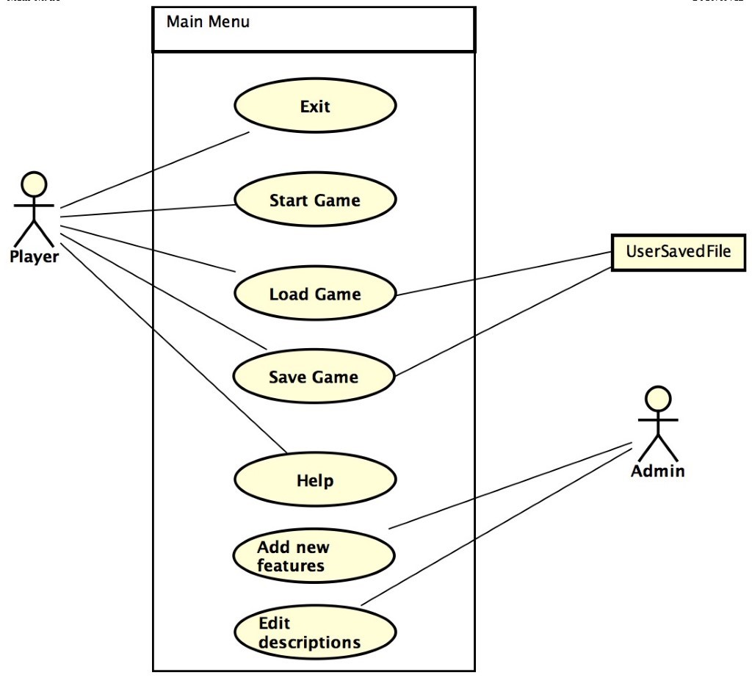
      - Purpose
This feature provides the user with a main screen to interact with.

      - Stimulus/Response Sequence
Exit: Player presses the exit button and the game closes.

Start Game: Player presses the start button and the game begins with a new game or a loaded game.

Load Game: Player presses this and selects the saved game to load in.

Save Game: Player presses to save the current game to a save file.

Help: Players presses for a list of help commands.

Add New Features: The administrator (admin) presses this to add new monsters or features to the game.

Edit Descriptions: The admin presses this and is able to edit the descriptions of objects already in the game.

      - Associated Functional Requirements

UID | 1FR
TITLE | Start Game
DESC | The player must be able to start a new or saved game from the main menu
DEP

UID | 2FR
TITLE | Load Game
DESC | The player must be able to load the information from a previously saved game.
DEP

UID | 3FR
TITLE | Save Game
DESC | The player must be able to save a game they have started
DEP | 1FR

UID | 4FR
TITLE | Help
DESC | At any time the player should be able to hit the help button and get a list of actions that can be performed given their place in the game.
DEP

UID | 5FR
TITLE | Exit
DESC | The player should be able to exit the game at any time, with or without saving first.
DEP

UID | 6FR
TITLE | Add New Features
DESC | The Admin should be able to add new features to the game
DEP

UID | 7FR
TITLE | Edit Descriptions
DESC | The Admin should be able to edit the descriptions of any object in the game.
DEP

Room Menu
BY: Michael Holtmann
      - Use Case Diagram
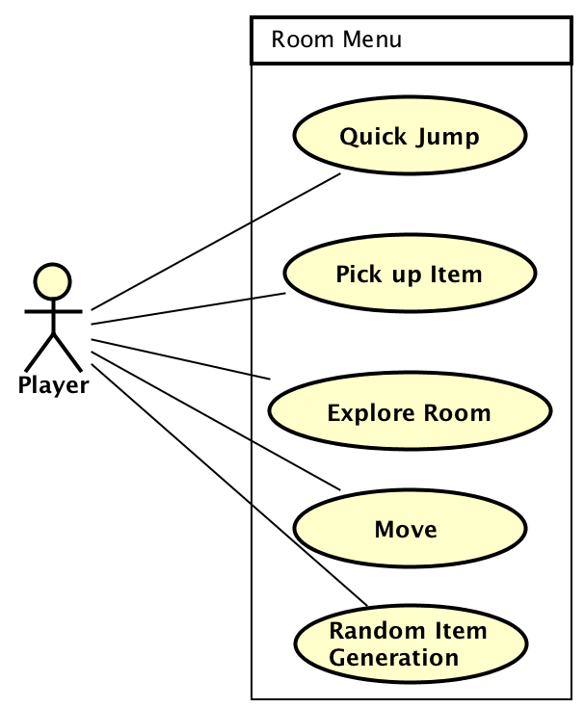
      - Purpose

This feature provides the user with the functions of actions within the room.

      - Stimulus/Response Sequence

Quick Jump: Player presses this button to have the ability to quickly jump back to a few main rooms ones they are been visited and powered up. (Command Center – r19, Ships AI – r31, Engine Room – r25, Communications - r22)

Pick up Item: Player presses the Pick-up Item button to investigates and pick up items that are in the room or dropped by monsters.

Explore Room: This gives room description controller and happens when they player enters the room.

Move: Player presses to pick and move through a door.

      - Associated Functional Requirements

UID | 8FR
TITLE | Quick Jump
DESC | The system should allow the player to pick a key room to travel back to at any point and any locations. The rooms to travel to must be visited and powered up with e-cells.
DEP | 1FR

UID | 9FR
TITLE | Pick up Item
DESC | The system should allow the player to view a description of an item and then have the option to take it or leave it. The player has to be in the same room.
DEP | 1FR

UID | 10FR
TITLE | Explore the Room
DESC | Upon entering the room the system will display the room and door description
DEP | 1FR

UID | 11FR
TITLE | Move
DESC | The system will take the players input of which room to move too. The player can only move to the rooms that are attached.
DEP | 1FR

UID | 16FR
TITLE | Random Item Generation
DESC | When entering a room, the system will randomly decide if a monster is present and what type. It will also randomly decide if a concussion grenade is found in the room.
DEP | 1FR

Fight Monster
By: Marcus Moss
      - Use Case

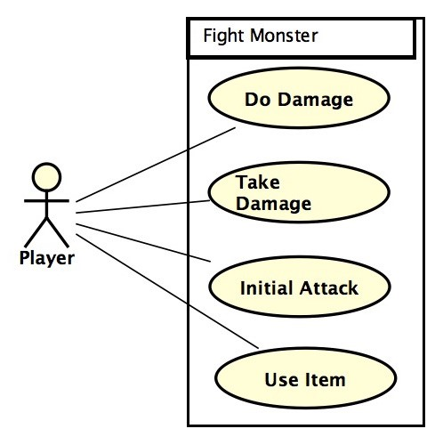
      - Purpose

This feature provides the user interaction with the monsters.

      - Stimulus/Response Sequence

Do Damage: By attacking, the player is able to deal damage to the monster, lowering its remaining health. It will die once it health becomes 0 or less.

Take Damage: When attacked, the player takes damage, lowering their remaining health. They will die once their health becomes 0, resulting in a game over.

Initial Attack: The "initial attack" is when the player notices the monster, which includes a description of it.

Use Item: By pressing the "Use Item" button the system will display the list of usable items during the fight. Includes health kits, grenades, and other weapons.

      - Associated Functional Requirements

UID | 17FR
TITLE | Do Damage
DESC | The damage system for the game for the player to damage monsters.
DEP | 1FR

UID | 18FR
TITLE | Take Damage
DESC | The damage system for the game for the monsters to damage players.
DEP | 1Fr

UID | 19FR
TITLE | Initial Attack
DESC | The system for placing the player into a battle.
DEP | 1FR

UID | 20FR
TITLE | Use Item
DESC | This system allows the player to use health items, use grenades, or switch weapons during battle during their turn.
DEP | 1FR

Solve Puzzle
      - Puzzle Use Case Diagram
(Done by Daniel)
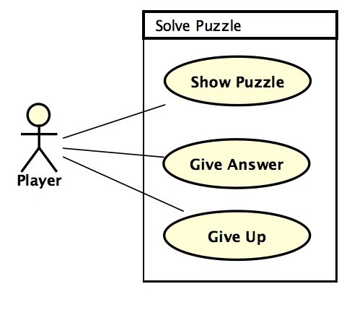
      - Purpose

This feature provides the user interaction with the puzzles

      - Stimulus/Response Sequence

Show puzzle: Press the show button to view puzzle.
Response: Puzzle is displayed

Give Answer: Text box for response to the puzzle
Response: Display correct or Try again

Give Up: Press give up button to exit the puzzle interaction
Response: Closes puzzle display

      - Associated Functional Requirements

UID | 12FR
TITLE | Show Puzzle
DESC | The system should allow the player to view the puzzle
DEP | 1FR

UID | 13FR
TITLE | Give Answer
DESC | The system should allow the player to answer the puzzle that is displayed, and give the option to try again if answer is incorrect
DEP | 1FR

UID | 14FR
TITLE | Give Up
DESC | The system should allow the player to choose to give up and continue playing
DEP | 1FR

Performance Requirements
The game needs to run on any computer. It should take no longer than 30 seconds to load or save a game.

Design Constraints
The system will be a non-graphics based system

Software System Attributes
Not Applicable
3.5.1 Reliability
The system should not crash in the middle of the game.

3.5.2 Availability
The game should run on any desktop computer.

3.5.3 Security
Not applicable

3.5.4 Maintainability

Logical Database Requirements
This system does not require a database.

Other Requirements
The system has no other requirements.

